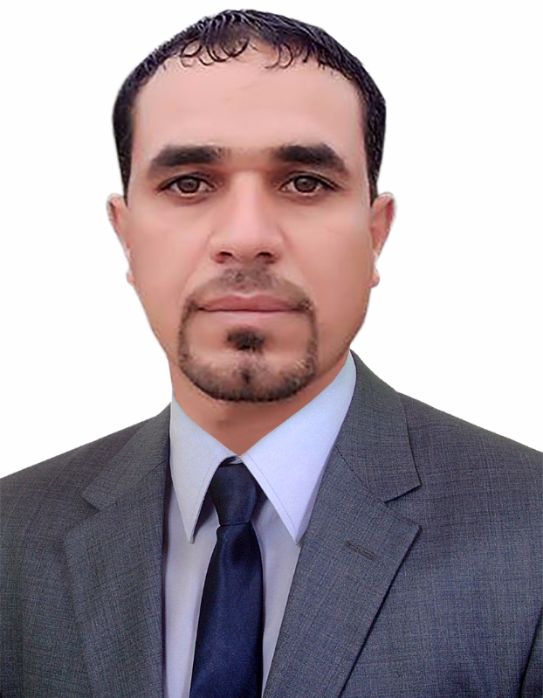

personal detials & Contact Information

* **Name** : Alaa Jasim Qzar
* **Date Of Birth** : 09.07.1986
* **Address** : Iraq, missan
* **Telephone** : +964 770 690 5179
* **E-mail Address** : 🖂🖳 [Alaag50@gmail.com](mailto:Alaag50@gmail.com)
* Education: 2010 – 2011
* Technical institute in Missan
* Department of Account

**Languages:**

* English, Arabic

Employments

* Al Emad Group Company For Shipping and Customs Clearance,(coordinator)2012-2013
* Total industrial Oils ( sales representative)2013-2014
* Sahara Middle East For Oil Services. 2014-2015
* Halliburton oil services (store). 2015-2016
* Lafarge Cement ( sales representative) 2016-2017

Computers Skills

* Microsoft office all
* Internet🖳